VGA & USB, AUDIO, RS232, IR CAT5 Extender
ITEM NO.: VKM03 VGA & USB with Stereo Audio, RS232, IR CAT5 Extender

The VKM03 VGA, USB with Stereo Audio, RS232,IR CAT5 extender design for extends all signal over one CAT5 up to 150 meters, with local VGA monitor output. It provides superior video quality up to 1920 x 1080 resolution, and using cost effective Cat5e cable, instead of VGA, audio, RS232 cables, for a easy, neater and reliable installation. It is optimized for applications at digital signage, home network integration, industrial control, security, and KVM extension.

Features:
- Extend VGA, stereo audio, RS232, IR and USB signals over one CAT5E/CAT6 cable.
- USB port support USB 2.0, USB 1.0 & USB 1.1
- Transmitter unit built in VGA loop output.
- Receiver unit with 4 ports USB devices, to extend USB 2.0 peripheral devices, such as flash disk, hard disk, keyboard, mouse, etc.
- Supports up to 1920 x 1080.
- Transmission range up to 150 meters.
- Plug and play for easy operation.
- Perfect for control remote machines and security monitoring systems, digital signage application.
- Optional model: SR01 signal repeater for longer distance application.

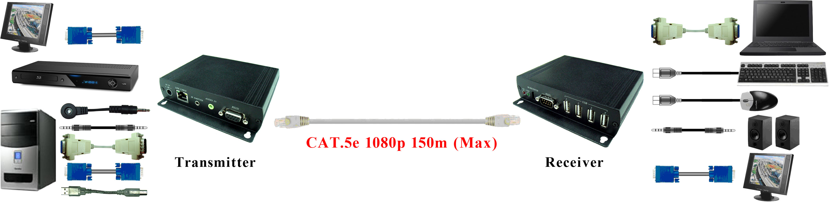

Optional Model: order separately
SR01 Signal Repeater
- Extend data signal over CAT5 cable.
- Application for UE02 USB CAT5 Extender up to 240 meters.
- Application for VKM03 VGA+USB CAT5 Extender up to 240 meters.
- Work with SR01, to extend VKM03 VGA, USB, RS232, audio signal only, without IR function.
- Built in LED status indication.
- External power required.
- Plug and play for easy installation.

Work with VKM03 CAT5 Extender:

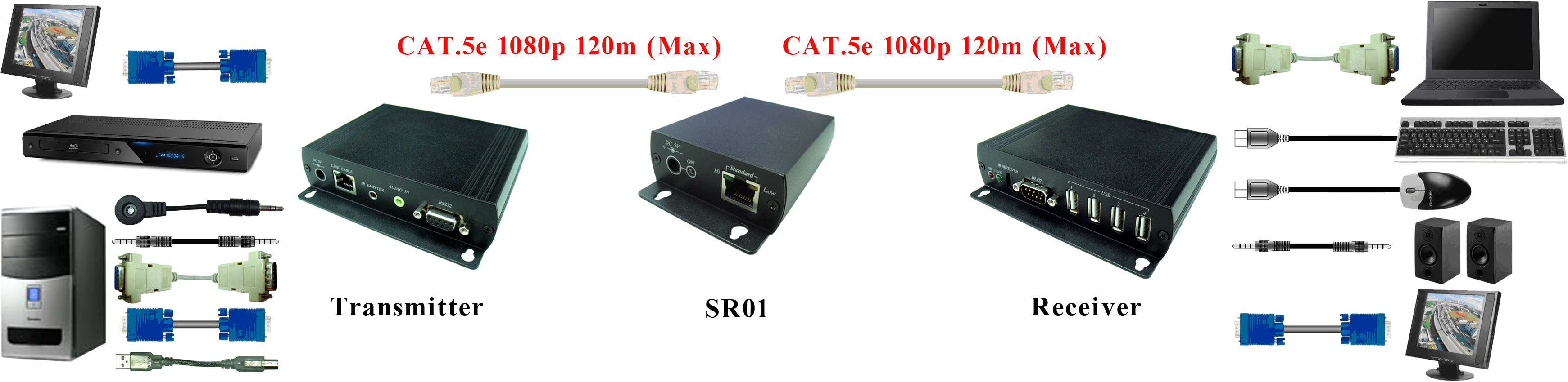

Panel View:
Transmitter
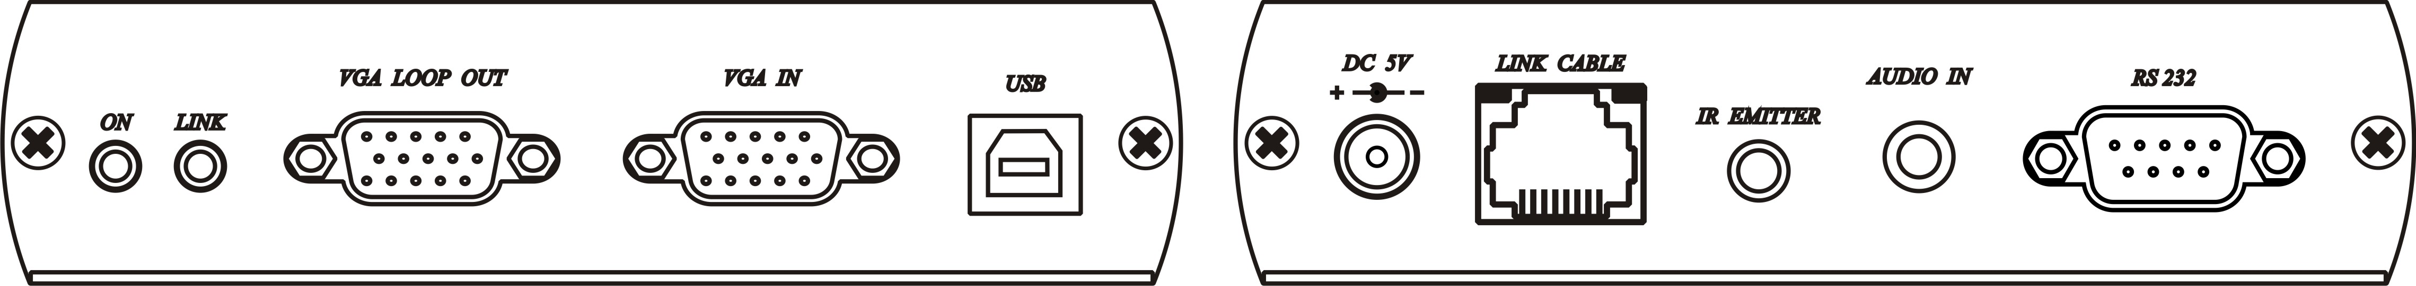
Receiver
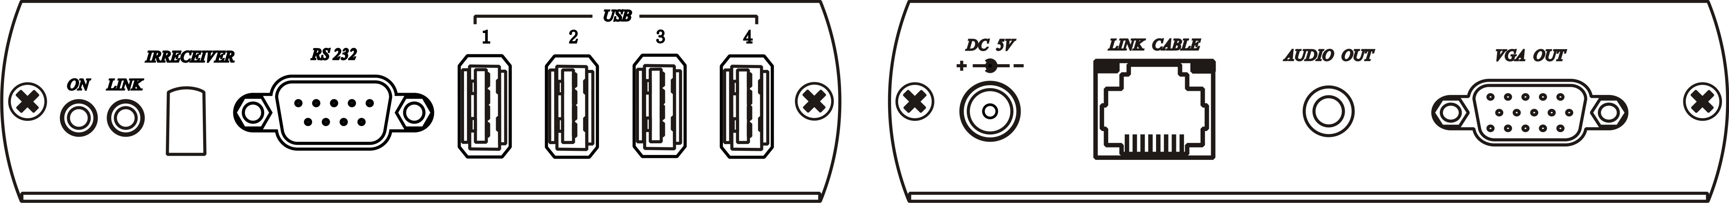

Cable:

Video Link cable using high quality CAT5E UTP/STP/FTP or CAT6 UTP cable.

RJ45 Define:
Link Cable ( TIA/EIA-568-B )
1. Orange-white Data 1 +
2. Orange Data 1 -
3. Green-white Data 2 +
4. Blue Data 3 +
5. Blue-white Data 3 -
6. Green Data 2 -
7. Brown-white Data 4 +
8. Brown Data 4 -

LED Indication Status:
Power On (power )
Link Flash ( under linking )
On ( linking )

RJ-45
Green Flash (Data transmission )
Orange On (linking)

Note: IR receiving angle ±55degree, emitting angle 30degree，distance reach to 3-5 meters.

Specification:

ITEM NO. | VKM03T | VKM03R
Support Resolution | Up to 1920 x 1080 @ 85 Hz
Transmission Distance | Up to 150 (Max)
Video Input Signals | RGB Analog (75Ω, 0.7Vp-p) Sync Signal H/V Separated (TTL)
VGA Connector | 15-pin D-Sub Female x 1 | 15-pin D-Sub Female x 2
USB Connector | B-Type x 1 | A-Type x 4
RS232 Connector | DB9(Female) x 1 | DB9(Male) x 1
Audio Connector | 3.5 Phone Jack x1 | 3.5 Phone Jack x1
IR Connector | 3.5 Phone Jack x1 | x
Link Connector | 1 x RJ-45
Power Supply | DC5V 2Amp | DC5V 2Amp
Power Consumption | 1.1Amp | 1.1Amp
Temperature | Operation: 0 to 55℃, Storage: -20 TO 85℃, Humidity: up to 95%
Dimensions W x H x D mm | 125*120.5*30 (mm) | 125*120.5*30 (mm)
Weight g | 350g | 350g

